Cloud Storage: Qwik Start - CLI/SDK

30 minutes1 Credit

Rate Lab

**GSP074**



**Overview**

Cloud Storage allows world-wide storage and retrieval of any amount of data at any time. You can use Cloud Storage for a range of scenarios including serving website content, storing data for archival and disaster recovery, or distributing large data objects to users via direct download.

In this hands-on lab you will learn how to create a storage bucket, upload objects to it, create folders and subfolders in it, and make objects publicly accessible using the Google Cloud command line.

Throughout this lab you'll be able to verify your work in the Console by going to **Navigation menu** > **Storage**. You'll just need to refresh your browser after each command is run to see the new items you've created.

**Setup and Requirements**

Qwiklabs setup

**Before you click the Start Lab button**

Read these instructions. Labs are timed and you cannot pause them. The timer, which starts when you click **Start Lab**, shows how long Google Cloud resources will be made available to you.

This Qwiklabs hands-on lab lets you do the lab activities yourself in a real cloud environment, not in a simulation or demo environment. It does so by giving you new, temporary credentials that you use to sign in and access Google Cloud for the duration of the lab.

**What you need**

To complete this lab, you need:

* Access to a standard internet browser (Chrome browser recommended).
* Time to complete the lab.

**Note:** If you already have your own personal Google Cloud account or project, do not use it for this lab.

**Note:** If you are using a Pixelbook, open an Incognito window to run this lab.

**How to start your lab and sign in to the Google Cloud Console**

1. Click the **Start Lab** button. If you need to pay for the lab, a pop-up opens for you to select your payment method. On the left is a panel populated with the temporary credentials that you must use for this lab.

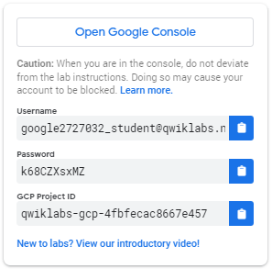

1. Copy the username, and then click **Open Google Console**. The lab spins up resources, and then opens another tab that shows the **Sign in** page.

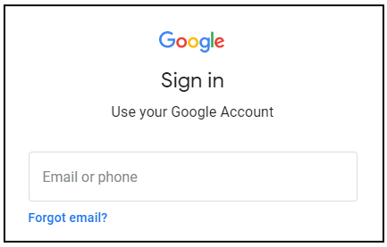

***Tip:*** Open the tabs in separate windows, side-by-side.

If you see the **Choose an account** page, click **Use Another Account**. 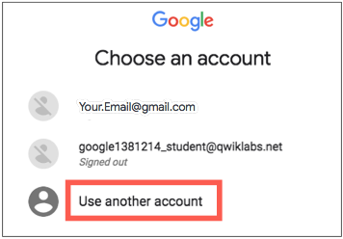

1. In the **Sign in** page, paste the username that you copied from the Connection Details panel. Then copy and paste the password.

***Important:*** You must use the credentials from the Connection Details panel. Do not use your Qwiklabs credentials. If you have your own Google Cloud account, do not use it for this lab (avoids incurring charges).

1. Click through the subsequent pages:
   * Accept the terms and conditions.
   * Do not add recovery options or two-factor authentication (because this is a temporary account).
   * Do not sign up for free trials.

After a few moments, the Cloud Console opens in this tab.

**Note:** You can view the menu with a list of Google Cloud Products and Services by clicking the **Navigation menu** at the top-left. 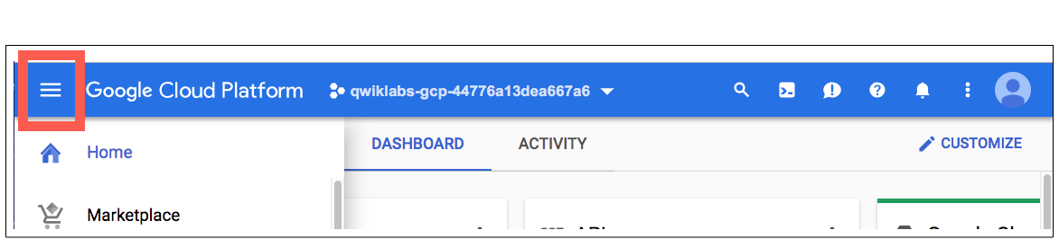

The Google Cloud Shell

Activate Cloud Shell

Cloud Shell is a virtual machine that is loaded with development tools. It offers a persistent 5GB home directory and runs on the Google Cloud. Cloud Shell provides command-line access to your Google Cloud resources.

In the Cloud Console, in the top right toolbar, click the **Activate Cloud Shell** button.

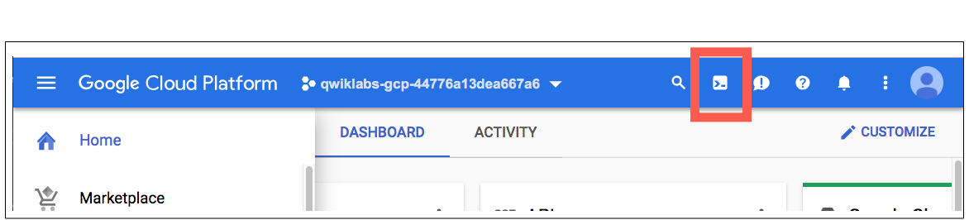

Click **Continue**.

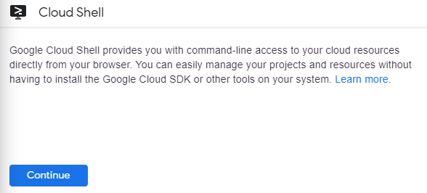

It takes a few moments to provision and connect to the environment. When you are connected, you are already authenticated, and the project is set to your *PROJECT\_ID*. For example:

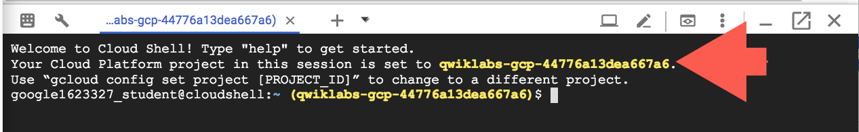

gcloud is the command-line tool for Google Cloud. It comes pre-installed on Cloud Shell and supports tab-completion.

You can list the active account name with this command:

gcloud auth list

(Output)

Credentialed accounts:

- <myaccount>@<mydomain>.com (active)

(Example output)

Credentialed accounts:

- google1623327\_student@qwiklabs.net

You can list the project ID with this command:

gcloud config list project

(Output)

[core]

project = <project\_ID>

(Example output)

[core]

project = qwiklabs-gcp-44776a13dea667a6

For full documentation of gcloud see the [gcloud command-line tool overview](https://cloud.google.com/sdk/gcloud" \t "_blank).

Create a bucket

Run the gsutil mb command and replace with a unique name to create a bucket:

gsutil mb gs://YOUR-BUCKET-NAME/

**Bucket naming rules:**

* Do not include sensitive information in the bucket name, because the bucket namespace is global and publicly visible.
* Bucket names must contain only lowercase letters, numbers, dashes (-), underscores (\_), and dots (.). Names containing dots require [verification](https://cloud.google.com/storage/docs/domain-name-verification).
* Bucket names must start and end with a number or letter.
* Bucket names must contain 3 to 63 characters. Names containing dots can contain up to 222 characters, but each dot-separated component can be no longer than 63 characters.
* Bucket names cannot be represented as an IP address in dotted-decimal notation (for example, 192.168.5.4).
* Bucket names cannot begin with the "goog" prefix.
* Bucket names cannot contain "google" or close misspellings of "google".
* Also, for DNS compliance and future compatibility, you should not use underscores (\_) or have a period adjacent to another period or dash. For example, ".." or "-." or ".-" are not valid in DNS names.

If successful, the command returns:

Creating gs://YOUR-BUCKET-NAME/...

You've just created a bucket where you can store your stuff!

**Note:** If the bucket name is already taken, either by you or someone else, the command returns:

Creating gs://YOUR-BUCKET-NAME/... ServiceException: 409 Bucket YOUR-BUCKET-NAME already exists.

Try again with a different bucket name.

Test Completed Task

Click **Check my progress** to verify your performed task. If you successfully created Cloud Storage bucket, you will see an assessment score.

Create a cloud storage bucket.

Check my progress

**Test your Understanding**

Below are a multiple choice questions to reinforce your understanding of this lab's concepts. Answer them to the best of your abilities.

Each bucket has a default storage class, which you can specify when you create your bucket.



True



False

**Upload an object into your bucket**

Now upload an object into a bucket.

First, download this image to a temporary instance (ada.jpg) in Cloud Shell:

wget --output-document ada.jpg https://upload.wikimedia.org/wikipedia/commons/thumb/a/a4/Ada\_Lovelace\_portrait.jpg/800px-Ada\_Lovelace\_portrait.jpg

Use the gsutil cp command to upload the image from the location where you saved it to the bucket you created:

gsutil cp ada.jpg gs://YOUR-BUCKET-NAME

**Tip:** When typing your bucket name, you can use the tab key to autocomplete it.

You can see the image load into your bucket from the command line. You've just stored an object in your bucket!

Now remove the downloaded image:

rm ada.jpg

**Download an object from your bucket**

Use the gsutil cp command to download the image you stored in your bucket to Cloud Shell:

gsutil cp -r gs://YOUR-BUCKET-NAME/ada.jpg .

If successful, the command returns:

Copying gs://YOUR-BUCKET-NAME/ada.jpg...

/ [1 files][299.6 KiB/299.6 KiB]

Operation completed over 1 objects/299.6 KiB.

You've just downloaded the image from your bucket.

**Copy an object to a folder in the bucket**

Use the gsutil cp command to create a folder called image-folder and copy the image (ada.jpg) into it:

gsutil cp gs://YOUR-BUCKET-NAME/ada.jpg gs://YOUR-BUCKET-NAME/image-folder/

**Note:** Folders in Cloud Storage [have limitations](https://cloud.google.com/storage/docs/gsutil/addlhelp/HowSubdirectoriesWork) compared to local file systems, but many of the same operations are supported.

If successful, the command returns:

Copying gs://YOUR-BUCKET-NAME/ada.jpg [Content-Type=image/png]...

- [1 files] [ 299.6 KiB/ 299.6 KiB]

Operation completed over 1 objects/299.6 KiB

Now the image file has been copied into a new folder in your bucket.

Test Completed Task

Click **Check my progress** to verify your performed task. If you have successfully uploaded object in folder over cloud storage, you will see an assessment score.

Copy an object to a folder in the bucket (ada.jpg).

Check my progress

**List contents of a bucket or folder**

Use the gsutil ls command to list the contents of the bucket:

gsutil ls gs://YOUR-BUCKET-NAME

If successful, the command returns a message similar to:

gs://YOUR-BUCKET-NAME/ada.jpg

gs://YOUR-BUCKET-NAME/image-folder/

That's everything currently in your bucket.

**List details for an object**

Use the gsutil ls command, with the -l flag to get some details about the image file you uploaded to your bucket:

gsutil ls -l gs://YOUR-BUCKET-NAME/ada.jpg

If successful, the command returns a message similar to:

306768 2017-12-26T16:07:570Z gs://YOUR-BUCKET-NAME/ada.jpg

TOTAL: 1 objects, 30678 bytes (299.58 KiB)

Now you know the image's size and date of creation.

**Make your object publicly accessible**

Use the gsutil acl ch command to grant all users read permission for the object stored in your bucket:

gsutil acl ch -u AllUsers:R gs://YOUR-BUCKET-NAME/ada.jpg

If successful, the command returns:

Updated ACL on gs://YOUR-BUCKET-NAME/ada.jpg

Your image is now public, and can be made available to anyone.

Test Completed Task

Click **Check my progress** to verify your performed task. If you have successfully shared object from storage bucket, you will see an assessment score.

Make your object publicly accessible

Check my progress

Validate that your image is publicly available. Go to **Navigation menu** > **Storage**, then click on the name of your bucket. You should see your image with the **Public link** box. Click the **Copy URL** and open the URL in a new browser tab.

Who are you looking at? This is [Ada Lovelace](https://en.wikipedia.org/wiki/Ada_Lovelace), credited with being the first computer programmer. She worked with mathematician and computer pioneer Charles Babbage, who proposed the [Analytical Engine](https://en.wikipedia.org/wiki/Analytical_Engine). Her interest in the Analytical Engine lead to translating a paper on the machine by Italian mathematician Luigi Menabrea, adding her own extensive annotations. These notes are considered the first computer program - an algorithm designed to be carried out by the machine. She developed a vision of the capability of computers, going beyond number crunching, and examined how individuals and society relate to technology as a collaborative tool. **Citation:** Ada Lovelace, <https://commons.wikimedia.org/w/index.php?title=Ada_Lovelace&oldid=176490980> (last visited December 6, 2017).

**Test your Understanding**

Below are a multiple choice questions to reinforce your understanding of this lab's concepts. Answer them to the best of your abilities.

An access control list (ACL) is a mechanism you can use to define who has access to your buckets and objects.



True



False

**Remove public access**

To remove this permission, use the command:

gsutil acl ch -d AllUsers gs://YOUR-BUCKET-NAME/ada.jpg

If successful, the command returns:

Updated ACL on gs://YOUR-BUCKET-NAME/ada.jpg

You have removed public access to this object. You can verify this by clicking the **Refresh** button in the Console. The checkmark will be removed. If you reload the page with the image, you will now get an error.

**Test your Understanding**

Below are a multiple choice questions to reinforce your understanding of this lab's concepts. Answer them to the best of your abilities.

You can stop publicly sharing an object by removing permission entry that have:



allUsers



By removing project owner role



By updating storage class

Submit

Delete objects

Use the gsutil rm command to delete an object - the image file in your bucket:

gsutil rm gs://YOUR-BUCKET-NAME/ada.jpg

If successful, the command returns:

Removing gs://YOUR-BUCKET-NAME/ada.jpg...

Refresh the Console. The copy of the image file is no longer stored on Cloud Storage (though the copy you made in the image-folder/ folder still exists).

**Congratulations!**



Finish Your Quest

Continue your Quest with [Baseline: Infrastructure](https://google.qwiklabs.com/quests/33). A Quest is a series of related labs that form a learning path. Completing this Quest earns you the badge above, to recognize your achievement. You can make your badge (or badges) public and link to them in your online resume or social media account. [Enroll in this Quest](http://google.qwiklabs.com/learning_paths/33/enroll) and get immediate completion credit if you've taken this lab. [See other available Qwiklabs Quests](http://google.qwiklabs.com/catalog).

**Next Steps / Learn More**

This lab is also part of a series of labs called Qwik Starts. These labs are designed to give you a little taste of the many features available with Google Cloud. Search for "Qwik Starts" in the [lab catalog](https://google.qwiklabs.com/catalog) to find the next lab you'd like to take!

Google Cloud Training & Certification

...helps you make the most of Google Cloud technologies. [Our classes](https://cloud.google.com/training/courses) include technical skills and best practices to help you get up to speed quickly and continue your learning journey. We offer fundamental to advanced level training, with on-demand, live, and virtual options to suit your busy schedule. [Certifications](https://cloud.google.com/certification/) help you validate and prove your skill and expertise in Google Cloud technologies.

Manual Last Updated September 29, 2020

Lab Last Tested September 29, 2020

Copyright 2020 Google LLC All rights reserved. Google and the Google logo are trademarks of Google LLC. All other company and product names may be trademarks of the respective companies with which they are associated.